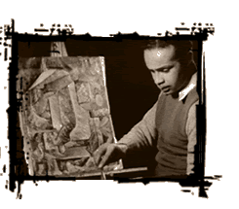
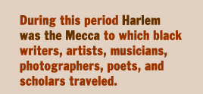
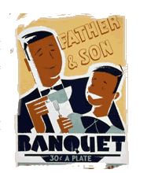
The Harlem Renaissance was the name given to the cultural, social, and artistic explosion that took place in Harlem between the end of World War I and the middle of the 1930s. During this period Harlem was a cultural center, drawing black writers, artists, musicians, photographers, poets, and scholars. Many had come from the South, fleeing its oppressive caste system in order to find a place where they could freely express their talents. Among those artists whose works achieved recognition were Langston Hughes and Claude McKay, Countee Cullen and Arna Bontemps, Zora Neale Hurston and Jean Toomer, Walter White and James Weldon Johnson. W.E.B. Du Bois encouraged talented artists to leave the South. Du Bois, then the editor of THE CRISIS magazine, the journal of the NAACP, was at the height of his fame and influence in the black community. THE CRISIS published the poems, stories, and visual works of many artists of the period. The Renaissance was more than a literary movement: It involved racial pride, fueled in part by the militancy of the "New Negro" demanding civil and political rights. The Renaissance incorporated jazz and the blues, attracting whites to Harlem speakeasies, where interracial couples danced. But the Renaissance had little impact on breaking down the rigid barriers of Jim Crow that separated the races. While it may have contributed to a certain relaxation of racial attitudes among young whites, perhaps its greatest impact was to reinforce race pride among blacks.

Mother to Son
BY LANGSTON HUGHES

Well, son, I’ll tell you:
Life for me ain’t been no crystal stair.
It’s had tacks in it,
And splinters,
And boards torn up,
And places with no carpet on the floor—
Bare.
But all the time
I’se been a-climbin’ on,
And reachin’ landin’s,
And turnin’ corners,
And sometimes goin’ in the dark
Where there ain’t been no light.
So boy, don’t you turn back.
Don’t you set down on the steps
’Cause you finds it’s kinder hard.
Don’t you fall now—
For I’se still goin’, honey,
I’se still climbin’,
And life for me ain’t been no crystal stair.
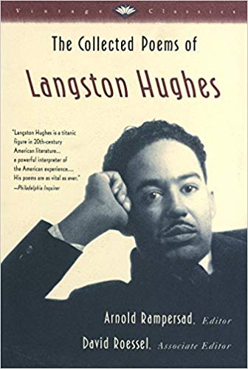
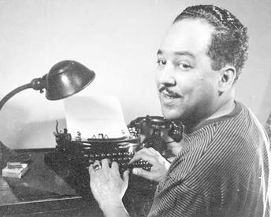

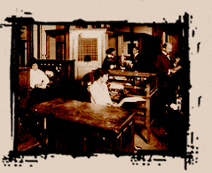
For the first twenty years of its existence, THE CRISIS, the official publication of the National Association for the Advancement of Colored People (NAACP), was almost synonymous with W.E.B. Du Bois. According to Mary White Ovington, a founder of the NAACP, the name of the magazine was the result of a conversation she had had with another founder, William English Walling. "We were," she wrote, "having an informal talk regarding
the new magazine. We touched the subject of poetry. There is a poem of Lowell's,' I said, 'that means more to me today than any other poem in the world -- The Present Crisis.' Mr. Walling looked up. 'The Crisis,' he said. 'There's the name for your magazine, THE CRISIS.'"
Du Bois resigned his professorship at Atlanta University to become editor of the magazine. He was 42 years old, and was already an internationally known scholar, teacher, historian, and spokesman for the cause of African Americans.
Du Bois made THE CRISIS into a militant voice in the crusade for black civil rights and for the rights of all people of color. The publication was a success. Starting with a circulation of 1,000 in its first year of publication, by 1918 THE CRISIS had more than 100,000 readers.
In eloquent prose, Du Bois launched rhetorical assaults against those who abused or denied the rights of blacks. The magazine attacked lynching and all forms of discrimination. When President Woodrow Wilson officially segregated the federal government in 1913, Du Bois sharply criticized him for doing so. In 1915, THE CRISIS called for a ban on the film THE BIRTH OF A NATION, which distorted Reconstruction by glorifying the Ku Klux Klan and denigrating blacks. The magazine became the voice of militant black America and Du Bois was the idol and hero of youth on college campuses. At the same time, THE CRISIS promoted the arts and the Harlem Renaissance. During the 1920s, it published articles, stories, and poems by black and white writers including Claude McKay, Langston Hughes, James Weldon Johnson, and H.L. Mencken. Du Bois featured the paintings and drawings of artists like William Edward Scott, John Henry Adams, and Laura Wheeler, among other artists. Du Bois resigned from the NAACP in 1934 after a conflict with Walter White. The magazine continues to be published today.
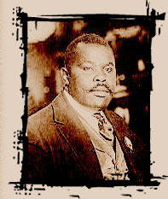 | Marcus Garvey was an ardent black nationalist who advocated self-help and unity among black people everywhere. Although born and raised in Jamaica, his greatest influence was in the United States. Before he came to America, Garvey had learned the printing trade, traveled extensively throughout Central America, and lived and studied in England for several years. He learned about African culture and the negative impact of colonialism on blacks. Convinced that the only way blacks could escape white exploitation and domination was through unity, Garvey launched, the Universal Negro Improvement Association and African Communities League -- which became known as the Universal Negro Improvement Association (UNIA) -- in August of 1914 in Jamaica. With the motto "One God! One Aim! One Destiny!," the association sought to unite blacks around the world.

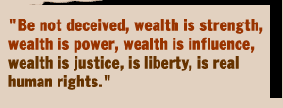
Garvey left for the United States in 1916, and while in New York gained a following for his movement as an orator, which led him to embark on a national speaking tour. He then established a branch of the UNIA in Harlem. The organization grew rapidly with the end of World War I and with dozens of chapters worldwide, it became the largest black organization in history.
In Harlem he published his most successful and important weekly newspaper, THE NEGRO WORLD, from 1918 to 1933. Its attack on colonialism led the British government to suppress the paper in the West Indies. THE NEGRO WORLD promoted Garvey's nationalist ideals and encouraged blacks to return to Africa. Millions of African Americans idolized him for praising the greatness of blacks. "Up You Mighty Race!" was one of his famous exhortations.
Garvey established the Black Star Line, a shipping company that raised more than $600,000 before collapsing in 1922, and the Negro Factories Corporation, which developed grocery stores, a restaurant, a laundry, a moving van fleet, and a publishing house. His brand of nationalism also led to bitter feuds with other black leaders, including African Americans and West Indians. The most notable of Garvey's rivals, W.E.B. Du Bois, described him as "dictatorial, domineering, inordinately vain and very suspicious." At one meeting he invited the Ku Klux Klan to share the platform with him in order to communicate to his followers that as whites take pride in their race, so too should blacks. In 1923, the U.S. authorities successfully prosecuted and convicted Garvey for mail fraud in connection with stock sales for the Black Star Line. Garvey served a two-year sentence and was then immediately deported.

