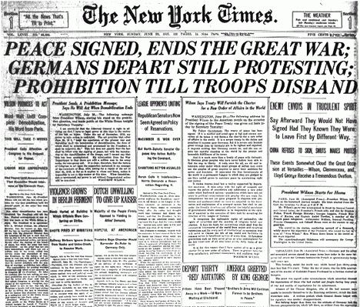

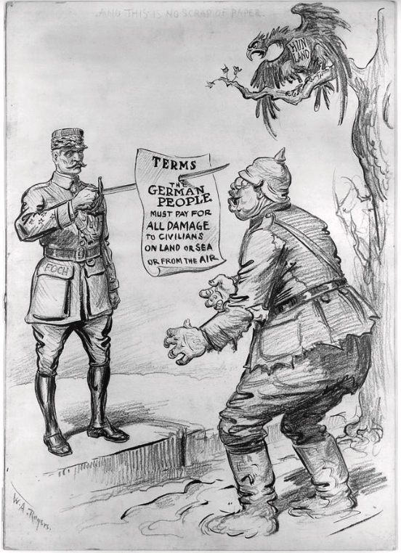
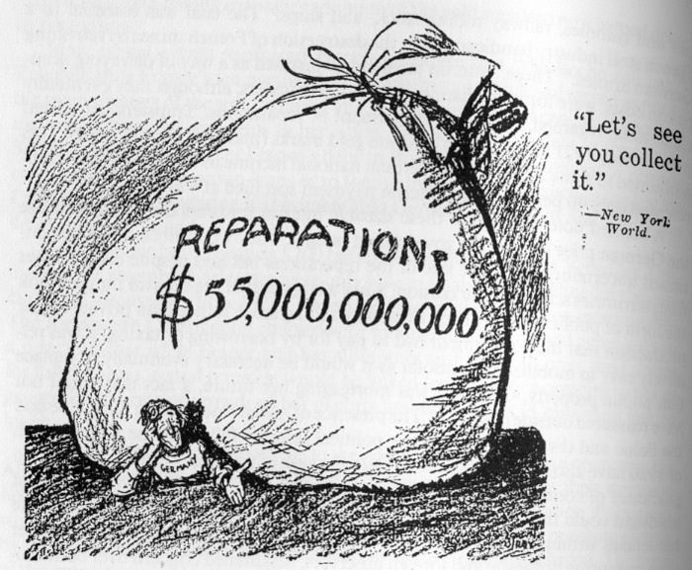

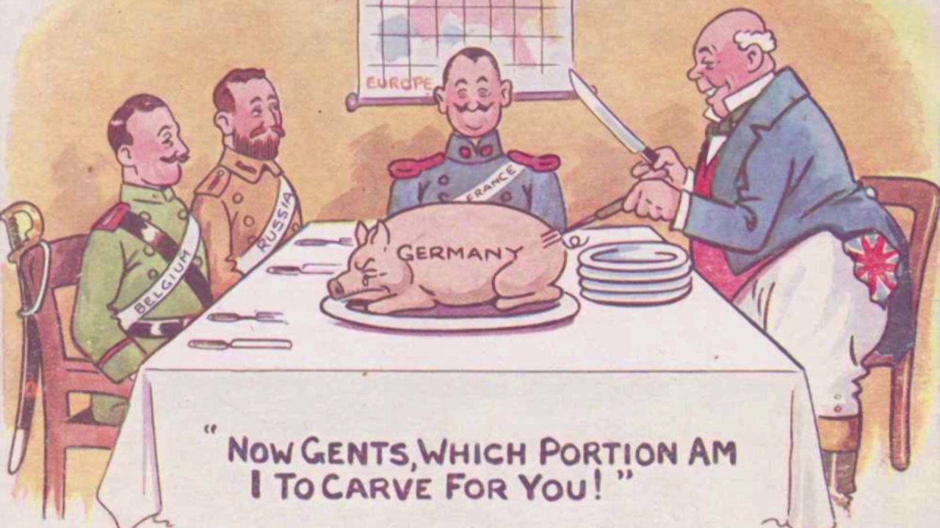

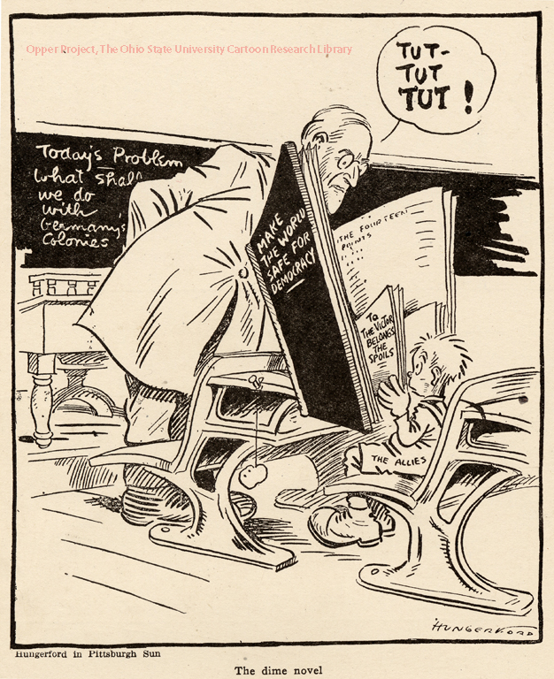

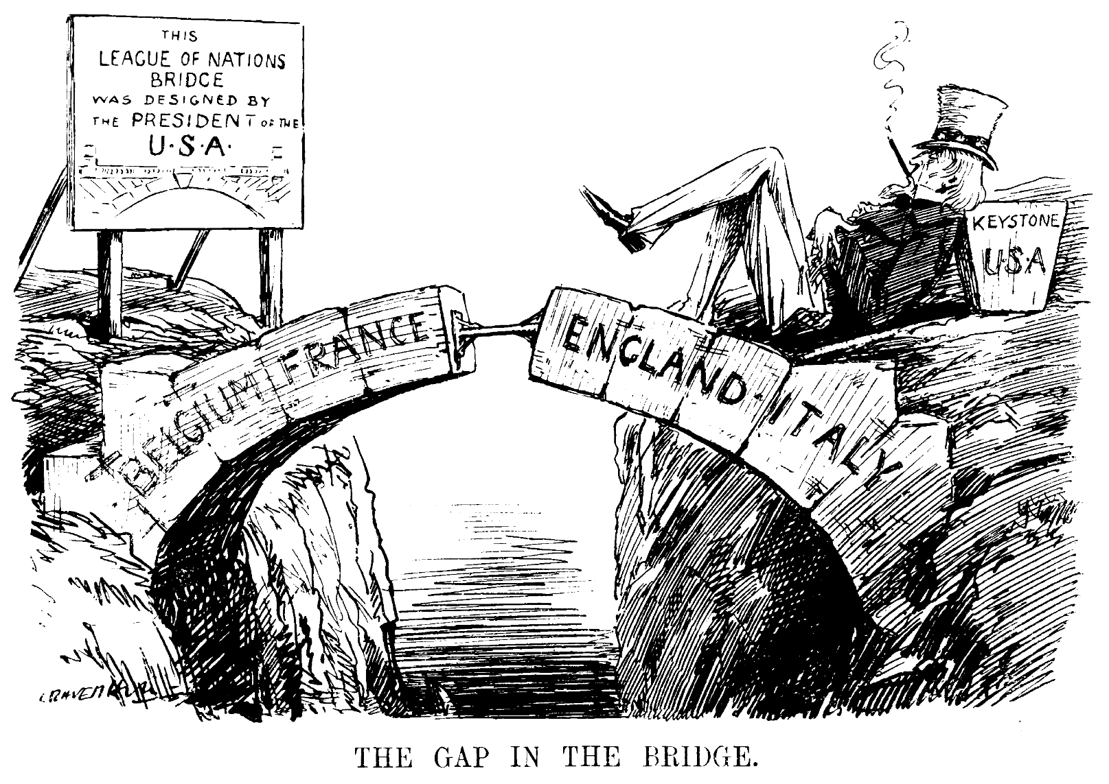

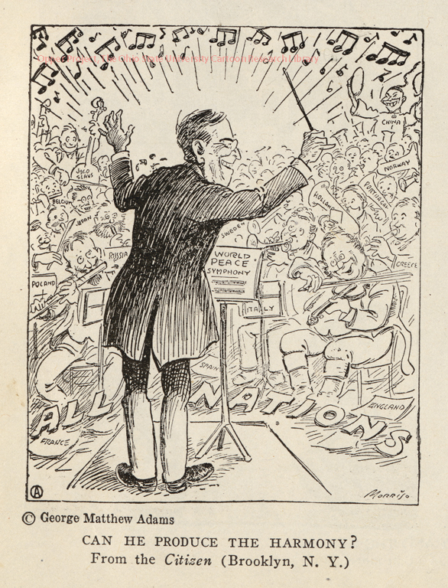

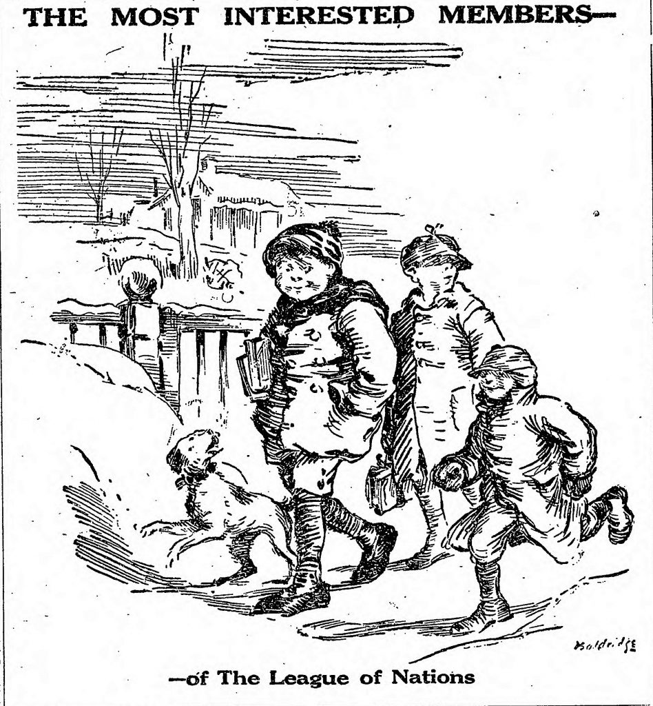

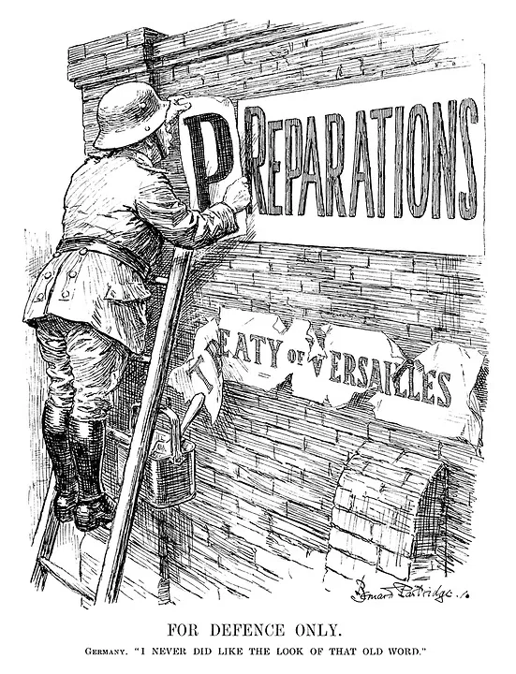

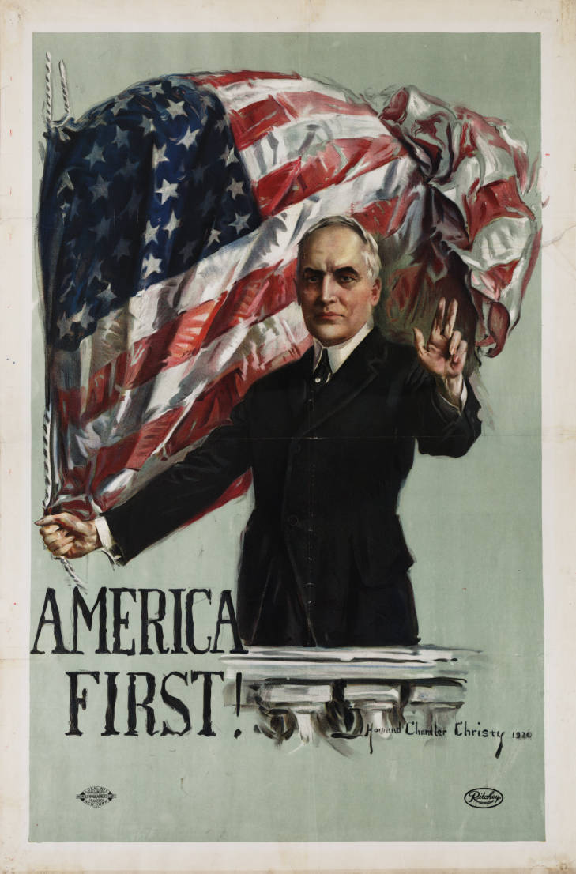

Poster from Warren Harding’s presidential campaign, 1919

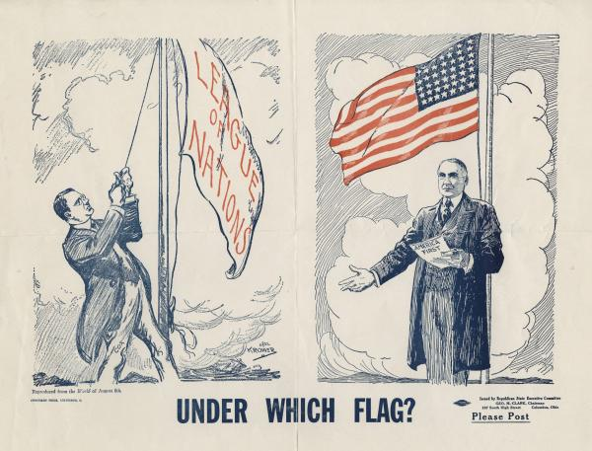

Poster from Warren Harding’s presidential campaign, 1919

Wilson’s 14 Points:
- No more secret agreements between countries. Diplomacy shall be open to the world.
- International seas shall be free to navigate during peace and war.
- There shall be free trade between the countries who accept the peace.
- There shall be a worldwide reduction in weapons and armies by all countries.
- Colonial claims over land and regions will be fair.
- Russia will be allowed to determine its own form of government. All German troops will leave Russian soil.
- German troops will evacuate Belgium and Belgium will be an independent country.
- France will regain all territory including the disputed land of Alsace-Lorraine.
- The borders of Italy will be established such that all Italians will be within the country of Italy.
- Austria-Hungary will be allowed to continue to be an independent country.
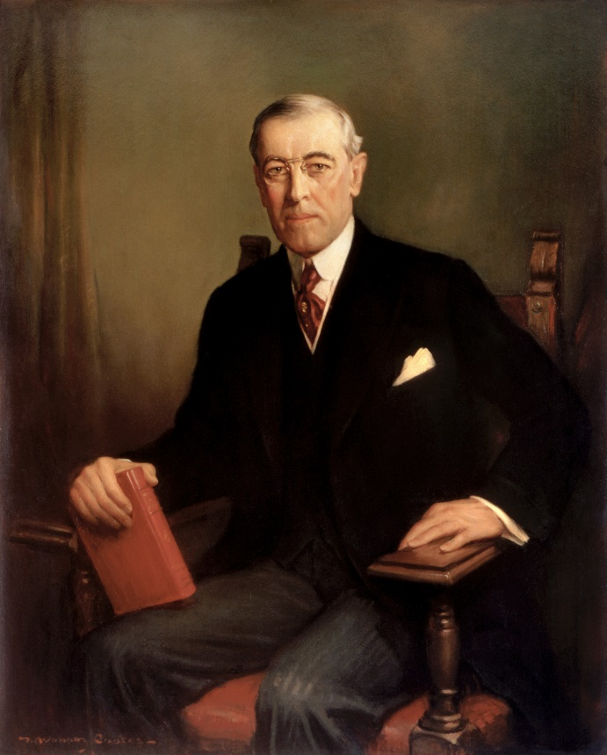
- The Central Powers will evacuate Serbia, Montenegro, and Romania leaving them as independent countries.
- The Turkish people of the Ottoman Empire will have their own country. Other nationalities under the Ottoman rule will also have security.
- Poland shall be an independent country.
- A League of Nations will be formed that protects the independence of all countries no matter how big or small.

