Chapter 7 Learning Guide – Ethnicity

Key Issue 1 – Where Are Ethnicities Distributed?
Pgs. 206 - 217

Distribution of Ethnicities Within the United States

- Define ethnicity:

- Define race:

- In the chart below identify America’s four ethnic groups (other than “white”). Give their percentage of total U.S. population and shade in 4 colors the areas on the map in which they are clustered.

Ethnic Group | % of U.S. Population

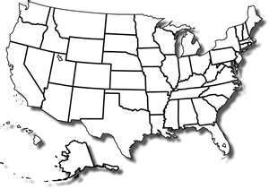

- What is the major Hispanic group in the U.S.?

- What are the major Asian groups in the U.S?

- Provide an example to illustrate that African-Americans or Hispanics in the U.S. are more urbanized.

- Complete the chart below to summarize the historic migration patterns of African-Americans.
Migration from Africa | Migration to the North | Migration Within Cities (ghetto)

Differentiating Ethnicity & Race

In the terms of the concept of race…

- What is the “problem” with the way the U.S. Census Bureau defines “Asian”?

- What is the difference between “African-American” and “black”?

- How does the U.S. Census Bureau consider Hispanic/Latino?

- What is racism?

Describe the following concepts dealing with the geography of race (#s 12 – 14).

- “Separate But Equal”

- “White Flight”

- “Blockbusting”

Case Study in Division By Race South Africa (Complete the case study as organized below)

- Define apartheid:

- Explain the key components of the apartheid system:

- Complete the following timeline of South African history and annotate the map of 10 homelands.
1652 –

1795 –

1948 –

1991 –

1994 -
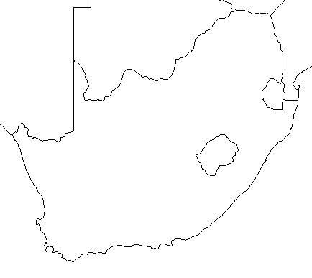
Chapter 7 Learning Guide – Ethnicity

Key Issue 2 – Why Have Ethnicities Been Transformed Into Nationalities?
Pgs. 217 – 224

Rise of Nationalities

- Define nationality:

- Though they are very similar, use the chart below to show how nationality differs from ethnicity.

Ethnicity | Nationality

- Define self-determination:

- Define nation-state:

- Why is Denmark a fairly good example of a nation-state?

- Two regions of Denmark prevent the country from being a “perfect” nation-state. List and describe them in the chart below

Denmark’s Non-Danish Regions
Region: | Region:
Description: | Description:
- Shade and label Denmark and her territories on this map of the North Atlantic region.

- What is nationalism?

- How do nations and states foster it?

- What are centripetal forces?

Multinational States

- What is a multiethnic state? Give an example.

- What is a multinational state? Describe in detail how the United Kingdom is an example.

- When the Soviet Union dissolved into 15 countries in the 1990s, the new countries were based on ethnicities. Other than Russia, they can be divided into 4 groups based on their location. Complete the chart below to indicate the countries in each group. NOTE: Be sure to look at the map on pg. 220 to familiarize yourself with the location of these countries.

Baltic Region
(3 states)
Eastern Europe
(3 states)
Central Asia
(5 states)
Caucusus
(3 states)

- Note the major religion and language of each of the Baltic States.

- The ethnic divisions among the Eastern European states are blurred for what reasons?

- What did the majority of Moldovans want when they gained independence? Who opposed this?

- What religions and languages are most common in the Central Asian countries?

- Have there been ethnic problems in Central Asia? If so, where? If not, why not?

- How many different nationalities (ethnicities) are found in the country of Russia?

- Why are independence movements flourishing among these groups?

- Russia has resisted the independence movement in Chechnya for what TWO reasons?

- In the Caucusus region, there have been many problems with the new nations and ethnicities. Summarize the main problems and note specifics of regions and peoples for each.

Azeris (Azerbaijan)
Georgians (Georgia)
Armenians (Armenia)

- Using Figure 7-19, what’s the main problem with the Caucusus region?

Revival of Ethnic Identity

- How did Communists suppress the issues of ethnicity and nationalism? (Give several examples)

- With the fall of Communist governments in the 1990s, what kinds of problems have arisen in what places? Why?

Chapter 7 Learning Guide – Ethnicity

Key Issue 3 – Why Do Ethnicities Clash?
Pgs. 224 – 229

Ethnic Competition to Dominate Nationality

- Make notes on major issues in each of these ethnic conflicts as well as shade and annotate the map as necessary.

Case Study: Africa

Ethiopia & Eritrea | 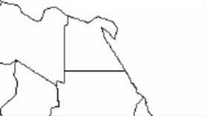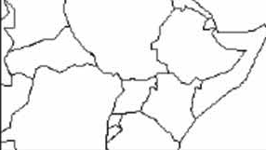
Sudan |  | Somalia
- Read “Ethnic Competition in Lebanon” and complete the case study by listing the religions of Lebanon and annotating them on the map provided (use map pg. 226).

Case Study Lebanon

Religions of Lebanon | 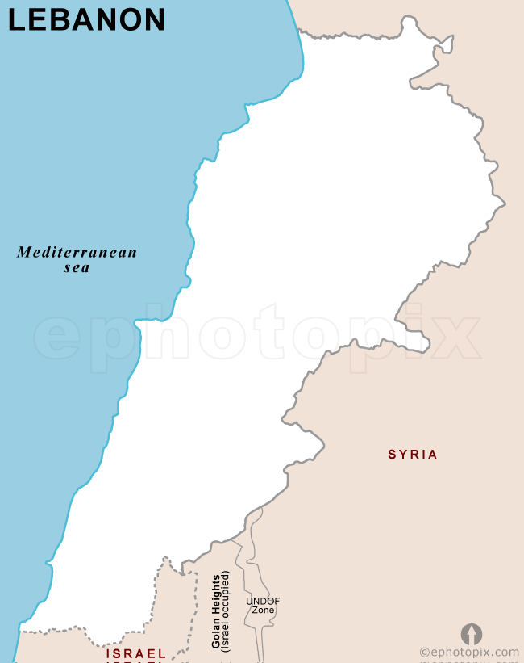

- How did Lebanon’s 1943 constitution seek to solve the religion problem?

The president…

The premier…

The speaker of the chamber of deputies…

The foreign minister…

- How has the make-up of the population changed since 1943?

- What happened in 1975? How has it been resolved?

Dividing Ethnicities Among More Than One State

- When the British ended colonial control of South Asia in 1947, how was the region divided politically, and how was the region divided ethnically (religiously)?

Answer #’s 7-13 regarding Forced Migration

- How many people found themselves on the “wrong side of the boundary” in the 1940s?

- How many Muslims migrated from India to West Pakistan (Pakistan, today)?

- How many Muslims migrated to East Pakistan (Bangladesh, today)?

- How many Hindus migrated from East and West Pakistan into India?

- What happened to many of the refugees as they traveled?

- Why is the region of Kashmir a problem?

- Note the following regions on the map below:

India  Pakistan  Bangladesh  Jammu & Kashmir  Sri Lanka  Nepal  Butan  Myanmar  China  Afghanistan | 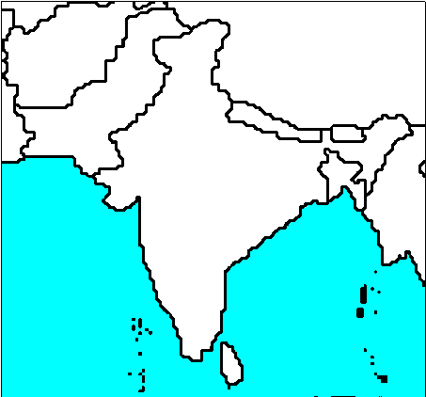

Sinhalese & Tamil in Sri Lanka Case Study

- Complete the chart that compares the two ethnicities of Sri Lanka in terms of language and religion.

Ethnic Group and % | Language (family, etc.) | Religion | Where?

- How has violence between these two groups (which goes back 2,000 years) been suppressed during the past 300 years?

- What occurred in 1948?

- Which group is unhappy? Why?

- Annotate the map of the religious-ethnic geography of the island of Ceylon, the country of Sri Lanka.

Chapter 7 Learning Guide – Ethnicity

Key Issue 4 – What is Ethnic Cleansing?
Pgs. 229 – 235

- Define ethnic cleansing:

- How is ethnic cleansing different than normal warfare?

Ethnic Cleansing in Europe

- List the countries of the Balkan Peninsula.

- List important/interesting facts regarding the creation of the post-WWI country of Yugoslavia.

- Regarding the Yugoslav refrain that was common during the rule of Josip Tito, identify the following of Yugoslavia’s:
FIVE NATIONALITIES…

FOUR LANGUAGES…

THREE RELIGIONS…

TWO ALPHABETS…

- What ethno-political problems did the country face after the death of Tito in the 80s and the fall of Communism in the 90s?

- Why did Serbs and Croats in Bosnia (aka Bosnia-Herzegovina) ethnically cleanse themselves of Bosnia Muslims?

- What was agreed upon at the accords signed between these rival ethnicities in Dayton, Ohio in 1996?

- Who got the best deal? Who got the worst deal? Explain.

Regarding the region of Kosovo, answer #’s 10-13.

- What country controlled Kosovo?

- What ethnic group lives in Kosovo (and %)?

- With the breakup of Yugoslavia, what began to happen in Kosovo?

- How did the U.S. and U.N. respond?

- Define balkanized:

- Define balkanization:

- If peace comes to the Balkan Peninsula in the next few years, why will it be “in a tragic way” according to the author of the textbook?

Ethnic Cleansing in Central Africa

- Give the historical background of the two rival groups in Central Africa’s countries of Rwanda and Burundi.

Hutus | Tutsis

18. What is the situation in Rwanda and Burundi today?

