Chapter 3 Learning Guide – Migration

Key Issue 1 – Why Do People Migrate?
Pgs. 78 - 85

- Define emigration:

- Define immigration:

Reasons for Migrating
- What are push factors and pull factors?

- Complete the chart below with specific examples of push and pull factors and where people are being pushed from and pulled to.
 | Push Factors | Pull Factors
Economic
Cultural
Environmental
- Define intervening obstacle:

- Briefly describe the role of physical geography in examining intervening obstacles and migration.

- Briefly describe the role of transportation in examining intervening obstacles and migration.

- Briefly describe the role of political concerns/laws in examining intervening obstacles and migration.

Distance of Migration
- Migration may be classified as either international or internal. What is the difference?

- What types of push factors are usually responsible for voluntary migration?

- What types of push factors are usually responsible for forced migration (refugees)?

- Briefly state what one would expect to occur, in terms of migration, in each stage of the demographic transition model, as it is applied to a migration transition.
MIGRATION TRANSITION
As Applied to the Demographic Transition Model
Stage 1 | Stage 2 | Stage 3 & 4
Characteristics of Migrants
- Complete the following chart from the reading.
Characteristics of Migrants
 | Who?
Gender | In the past…  Present trends…
Family Status? | In the past & still today…  Recent changes…

Chapter 3 Learning Guide – Migration

Key Issue 2 – Where are Migrants Distributed?
Pgs. 85 – 92

Global Migration Patterns

- Read the section, and then make 5 summary statements regarding global migration patterns.

U.S. Immigration Patterns
2. Finish this statement: The world’s third most populous country (the U.S.) is inhabited overwhelmingly by…

- In what stage of the Demographic Transition are most countries that send out immigrants?

- Annotate the graph below from your reading of pages 86-88. Be sure to label all “peaks” and “valleys” (as indicated by arrows) as to where immigrants came from during that time or why there was a decline in immigration. (know this graph!!)

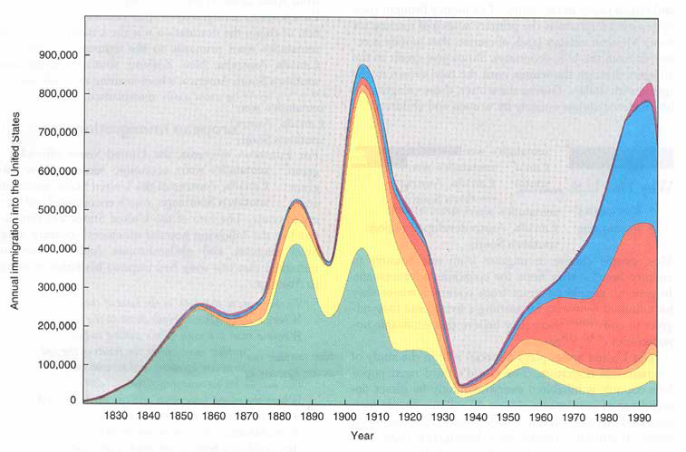

- What are the 3 countries that sent out the most immigrants from Asia in recent years?

- What caused immigration from Latin America to the United States to increase?

- Although the reasons people leave their countries to immigrate to the U.S. have not changed over time, what has changed here in the U.S.?

Impact of Immigration on the United States
- Complete the chart below.
European Immigration
What were some of the causes of European immigration to the United States? | What were some of the important effects of European immigration to the U.S. and other world regions?
- What are undocumented immigrants?

- Where do most undocumented immigrants in the U.S. come from?

- Read Destination of Immigrants Within the United States (pgs. 90-92) and annotate the map below. Be sure to indicate: Where are immigrants coming from? What states are those immigrants coming to?

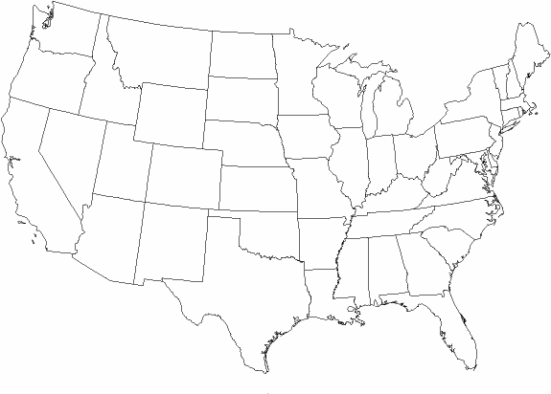

- Define chain migration:

Chapter 3 Learning Guide – Migration

Key Issue 3 – Why do Migrants Face Obstacles?
Pgs. 92 – 95

Immigration Policies of Host Countries

- What did the Quota Act (1921) and the National Origins Act (1924) do?

- How did they favor immigration from certain regions?

- How did the Immigration Act of 1965 change the existing quota laws?

- How was immigration law further changed in 1978? And presently?

- U.S. immigration law gives preferences to three groups. Identify them.

- Define brain drain:

- Define guest worker:

- Prepare notes on 3 case studies of immigration in the chart below.
Immigration to the U.S.: 3 Case Studies
Cuba | Haiti | Vietnam
 |  | 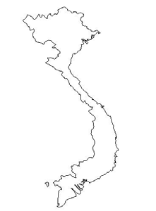
Cultural Challenges Faced While Living in Other Countries
- Carefully read this section. Then, complete the Venn diagram below to compare and contrast attitudes in the U.S. and Europe toward immigrants.
U.S. Attitudes Toward Immigrants | European Attitudes Toward Guest Workers

Chapter 3 Learning Guide – Migration

Key Issue 4 – Why do People Migrate Within a Country?
Pgs. 95 – 100

Migration Between Regions of a Country

- What is the most famous example of large-scale interregional migration in the U.S.?

- What is the “population center” (see Figure 3-16)?

- What was the first “intervening obstacle” which hindered American settlement of the interior of the continent?

- What developments in transportation eventually encouraged settlement to the Mississippi?

- Why was settlement of the Great Plains slow to come with settlers passing it by for California and the west coast?

- How did the railroads encourage settlement of the American interior?

- For what two reasons have people been migrating to the South in recent years?

- Use the chart on page 97 to calculate the net growth or loss of U.S. regions for 2007. Name the region on the map and place the appropriate number in each region.

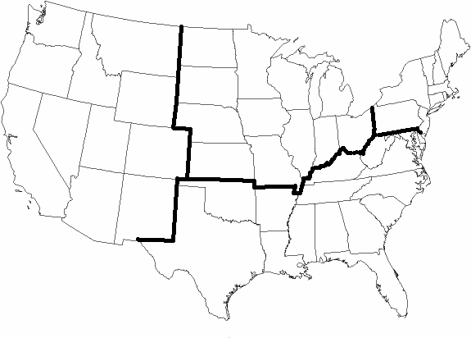

- Make appropriate notes in the chart below on 5 specific examples/case studies of interregional migration.
Russia
Where? | Why?
How?

Brazil
Where? | Why?
How?

Indonesia
Where? | Why?
How?

Europe | India
Migration Within One Region
- Define/describe each of the following terms, and summarize a single, important fact about its occurrence in the U.S.
 | Urbanization | Suburbanization | Counterurbanization
Definition
Significant Fact
in U.S.

