Chapter 8 Learning Guide – Political Geography

Key Issue 1 – Where Are States Located?
Pgs. 238 – 247

Problems of Defining States

- Define state:

- Define sovereignty:

- There is some disagreement about how many states there actually are in the world because of regions which may, or may not, actually be states. Complete the chart to demonstrate three cases.

Korea (North & South) | People’s Democratic Republic of China (China) and/or Republic of China (Taiwan) | Western Sahara or Sahrawi Republic
One state if you agree that… | One state if you agree that… | One state if you agree that…
Two states if you agree that… | Two states if you agree that… | No state if you agree that…

Varying Size of States

- List the 6 largest states in order.

- How many microstates are recognized? What do many have in common? List 6 that you can find on a map, and state where they are. (If you can only come up with 3 on your own, you’ll have to look up three more!)

Development of the State Concept

- Complete the graphic organizers on the topics indicated below as they related to the history of the concept of political states and their developments.

Ancient States
Early European States

- By definition, what is a colony?

- Define colonialism:

- Summarize three reasons Europeans sought colonies.

- Define imperialism:

- Which country had the largest empire? Second largest?

- Use the chart below to contrast the basic colonial policies of these two countries.

Colonial Practices of… | Colonial Practices of…

- List the largest remaining colonies in the world and who possesses each.

Chapter 8 Learning Guide – Political Geography

Key Issue 2 – Why Do Boundaries Cause Problems?
Pgs. 247 – 256

- Define boundary:

Shapes of States

- Complete the chart based on your reading. The text gives examples of African countries that you should provide (map pg. 250).

Shapes |  | Examples
Compact | Greatest advantage…
Elongated | Biggest problem…
Prorupted | Reason for prorupting the shape of a state…
Perforated | How is the perforator state dependent on the “perforatee”?
Fragmented | Different kinds…

- Define landlocked state:

- Where are most of the world’s landlocked states?

- Why there?

- What problems do landlocked states have?

- Shade and label all 15 of Africa’s landlocked states.

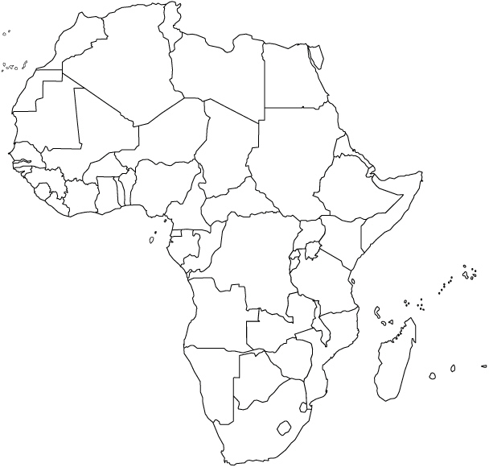

Types of Boundaries

- Define physical boundary:

- Define cultural boundary:

- Complete the chart below to describe the advantages of each type of physical boundary.

Deserts | Mountains | Water

- What are three types of cultural boundaries that have often been used? Give an example of each type of cultural boundary and describe.

Case Study: Cyprus

- Bullet in the most significant facts regarding the boundary and ethnic situation in Cyprus. Annotate the map as appropriate.
- Define frontier:

- List characteristics of frontiers:

Boundaries Inside States

- Define unitary state:

- Define federal state:

- Regarding unitary states, what are the three characteristics that tend to favor it for a country?

- Where are unitary states most common?

- Why is the federal state system more effective for larger states?

- List good examples of federal states that fulfill these conditions rather well.

- Why has tiny Belgium adopted a federal system?

- Why has enormous China adopted a unitary system?

- Multinational states often adopt unitary systems for what reason? Also, describe an example where this has occurred.

Case Study: France

- Describe the internal political organization of France in the box below.

France: Internal Political Organization
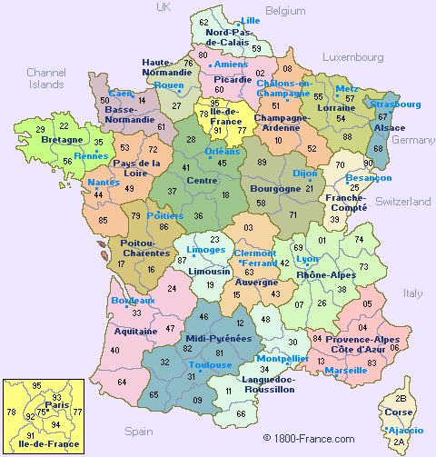

- Why are boundaries of legislative districts occasionally redrawn? How often is this done in the U.S.?

- How is this type of boundary redrawing different in the U.S. than in Europe?

- What is gerrymandering?

- What are the three types of gerrymandering? Explain them.

- How is gerrymandering combined with ethnicity for political use?

Chapter 8 Learning Guide – Political Geography

Key Issue 3 – Why Do States Cooperate With Each Other?
Pgs. 257 – 260

Political & Military Cooperation

- When was the United Nations established? By whom?

- Identify the reason for which membership in the UN grew significantly in each of the following periods.

1955
1960
1990s

- Who are the five permanent members of the Security Council?

- Identify some of the problems the UN faces as it attempts to operate and influence world affairs.

- Why is the idea of two superpowers a relatively new one?

- Define balance of power:

- Describe the purpose of NATO.

- Describe the purpose of the former “Warsaw Pact” countries.

- List 3 facts about the OSCE (Organization on Security & Cooperation in Europe).

- Complete the chart on notable non-military regional organizations.

Regional Organization | Members | Purpose
OAS (Organization of American States)
AU (African Union)
The Commonwealth

Economic Cooperation

- What states have joined the “superpowers” based on their economic successes? What former power has “slipped” from its earlier status?

- The leading (economic) superpower since the 1990s is not a single state. What is the leading (economic) superpower in the world today?

Answer #s 13-16 regarding the European Union

- When was it formed?

- By what states?

- For what purpose?

- What are some important changes in recent years?

Chapter 8 Learning Guide – Political Geography

Key Issue 4 – Why Has Terrorism Increased?
Pgs. 260 – 268

- By definition, what is terrorism?

- List typical methods/acts of terrorists.

Terrorism By Individuals & Organizations

- Why is terrorism different from other acts of political violence?

- List some places in which Americans were attacked by terrorists in the late 20th century.

In #s 5-9, identify each of the following terms as they relate to the terrorist organization known as Al-Qaeda.

- Osama bin-Laden:

- Afghanistan:

- Yemen & Somalia:

- “the base”:

- fatwa:
- In what ways does Al-Qaeda, its religious and political views, and its methods pose a challenge to Muslims?

- In what ways does Al-Qaeda, its religious and political views, and its methods pose a challenge to Americans?

State Support for Terrorism

- List three ways in which states (particularly in the Middle East in recent decades) have given support to terrorists.

- Note in which of the above ways each of the following states has supported terrorism and then briefly describe it.
State | Type of Support  (from question #12) | Brief Summary of Issues
Libya
Afghanistan
Iraq
Iran

