Name:__________________

RN 4.6: Causes of Depression p. 570-576
Prosperity Hides Troubles
1. Who were the three Republican presidents of the 1920s?
Warren Harding, Calvin Coolidge, and Herbert Hoover

2. How can you generalize life in America during the 1920s?
It seemed like an era of endless prosperity! (But not for everyone…)

3. What problems did farmers face?
Debts from WWI, prices of crops fell; they lived mostly on credit

4. How did the lifestyle of rural Americans differ from urban Americans?
Urban Americans experienced much more financial prosperity

5. What does uneven distribution of wealth mean?
A small amount of people own a HUGE part of the wealth

6. Describe how buying on the installment plan works?
Someone pays a small amount up front, and makes payments for the
rest over a period of months or years
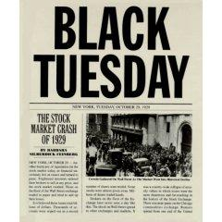
7. What was the result of Americans increasingly buying on credit?
Every year, Americans accumulated more debt!

The Stock Market Crashes
8. What happened on Black Tuesday?
The stock market collapsed → People lost entire fortunes in
a few hours!!

The Great Depression Begins
9. Great Depression:
A period from 1929-1941 when the economy faltered and
unemployment soared

10. What were three consequences of the stock market collapse?
- Many banks failed
- Businesses closed
- Workers lost their jobs (nearly 25% of all workers!!)

11. What effect did tariffs like the Hawley-Smoot Tariff have on the depression?
European countries responded by passing their own tariffs → destroyed
international trade!!

