American Imperialism Notes
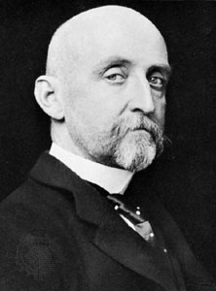
Reasons the US wanted to control other countries:
Wrote about how great empires needed great navies... and bases to sail from!
______________
______________

1. _________________________________________

2. _________________________________________

3. _________________________________________

4. _________________________________________

5. _________________________________________

The “splendid war” (so short and had so few casualties): ________________________________

In 1895, this European nation owned Cuba (but there were revolts!): ______________________

When exaggerated photos/headlines are used to sell newspapers: _________________________

When this ship blew up, Spain got the blame: _________________________________________

An aggressive, warlike form of nationalism: __________________________________________

The only Army regiment to see action in the Spanish-American War (and led by Teddy Roosevelt!):

______________________

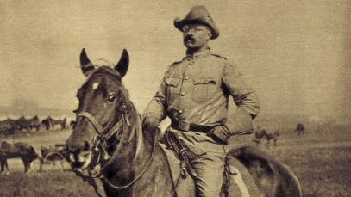
After ___________________________________, Spain had to give up Cuba, Puerto Rico, Guam, and the Philippines!!!!

_________________________________: President Roosevelt’s foreign policy; involved having a strong military.

_____________________________________: President Taft’s foreign policy; involved investing money abroad.

___________________________________: President Wilson’s
foreign policy; involved using humanitarian aid.
Stop: Review!
1) Two names:

2) Main idea:

3) What’s to blame:

4) What specific event:

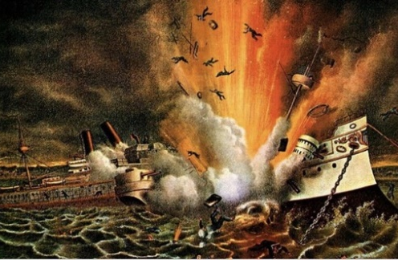

Commodore Matthew C. Perry’s journey in 1853 opened trade with: ______________________

The treaty to purchase ______________________ was originally criticized as “Seward’s Folly.”

Overthrown because the US wanted control over Hawaii: _______________________________

Established a civil government in Puerto Rico (but no voting!): ___________________________

Restricted the rights of Cubans and gave US “right to intervene”: _________________________

Nontraditional warfare; used by Filipinos against the US: _______________________________

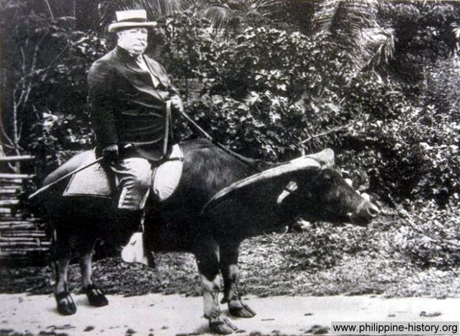
________________________________: US said they did not want to colonize China, only to trade

________________________________: US agreed to end Japanese segregation in San Francisco schools if Japan agreed to limit immigration to the US

_______________________________: a “good will” tour, but really to show off military strength
Stop: review!
What did President Theodore Roosevelt mean by his phrase: “Speak softly and carry a big stick”??
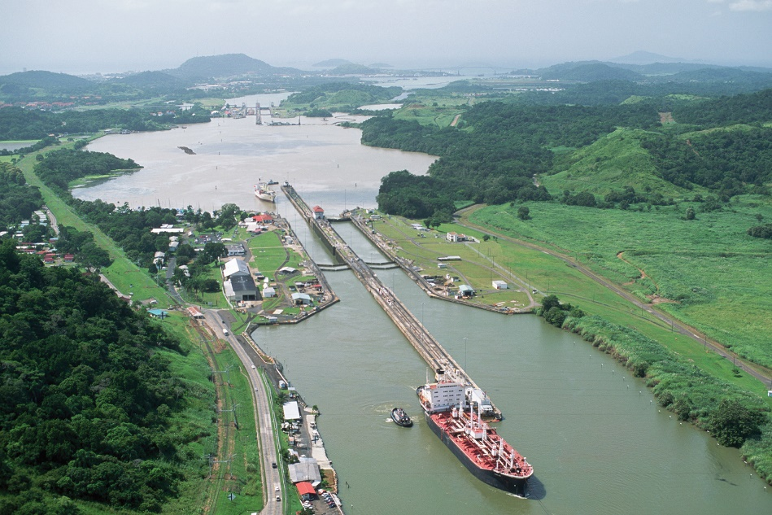
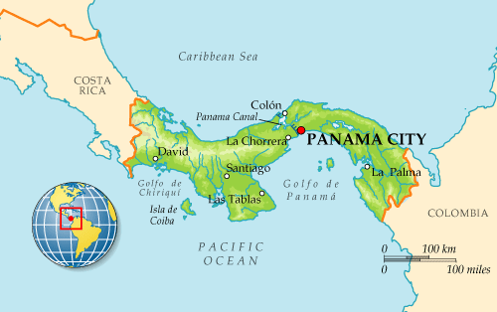

_______________________________
drastically cut down on travel time between the Pacific and the Atlantic Oceans!

